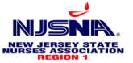

**Region 1:** Educational/Business Meeting

Saturday, March 22, 2025, 10 am - 12 pm

**Location:**

Romano Conference Center at Newton Medical Center

175 High Street, Newton, 07860, NJ

**Education:**

***Nursing Ethics: Bracing our Moral Agency***

**Elizabeth Bertolini, RN, MMH, HEC-C, CHPN**

**Clinical Nurse Ethicist**

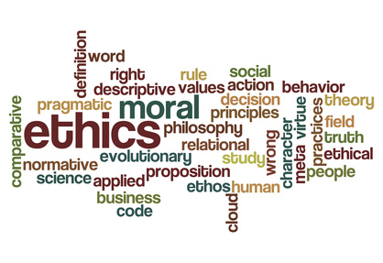

*Join fellow nurses and discover what we do for our Region 1 Nurses!* Not a member? Not a problem. This event is FREE, and nursing friends are welcome to attend!

**RSVP:** Karen Kinsley, Region 1 President 2024-2025 @ [karenknjsnar1@gmail.com](mailto:karenknjsnar1@gmail.com) or VP of Education Jacqueline Tierney @ [jtierney.njsna1@gmail.com](mailto:jtierney.njsna1@gmail.com)

**Collections:** Please donate a non-perishable food item to a local food bank.

**NJSNA Website for Region 1 - Microsite** https://njsna.org/regional-site/region-1/ 