  - 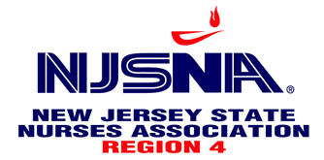

Education Committee Presents

Long COVID: Current Knowledge and Impact

Speaker:
Himani Patel, PharmD
Senior Medical Science Liaison- COVID-19
Gilead Sciences, Inc. Medical Affairs

Thursday, May 9, 2024
7 – 8 p.m.
NJSNA Headquarters
1479 Pennington Rd, Ewing Township, NJ 08618

Light refreshments will be served.
Please email njsnaregion444@gmail.com to register.

